***Lab Practical 02:***

*Study of different types of network cables & connectors and practically implement the cross-wired cable and straight through cable using clamping tool.*

***Practical Assignment 02:***

1. *List various networks cable and connectors. Also, write short description.*
2. *Give cross-wired cable and straight through cable diagram (Color Code wise).*

## *List various networks cable and connectors. Also, write short description.*

* + ***There are two types of Transmission Media.***

1. ***Guided Media***

*It is defined as the physical medium through which the signals are transmitted. It is also known as* ***Bounded media.***

* 1. *Twisted – Pair Cable*
  2. *Coaxial Cable*
  3. *Fiber Optic Cable*

1. ***Unguided Media***

*An unguided transmission transmits the electromagnetic waves without using any physical medium. Therefore it is also known as****wireless transmission****. In unguided media, air is the media through which the electromagnetic energy can flow easily.*

1. *Radio wave*
2. *Micro wave*
3. *Infrared wave*
4. ***Network Cable Name :*** *Twisted – Pair Cable*
   * ***Network Cable Type :***  *Guided*
   * ***Description*** *:*

*Twisted pair is a physical media made up of a pair of cables twisted with each other. A twisted pair cable is cheap as compared to other transmission media. Installation of the twisted pair cable is easy, and it is a lightweight cable. The frequency range for twisted pair cable is from 0 to 3.5KHz.*

*The degree of reduction in noise interference is determined by the number of turns per foot. Increasing the number of turns per foot decreases noise interference.*

* ***Types of Twisted pair :***

1. ***Shielded Twisted Pair***

* *A shielded twisted pair is a cable that contains the mesh surrounding the wire that allows the higher transmission rate.*
* *An installation of STP is easy.*
* *It has higher capacity as compared to unshielded twisted pair cable.*
* *It is shielded that provides the higher data transmission rate.*

***Diagram :***

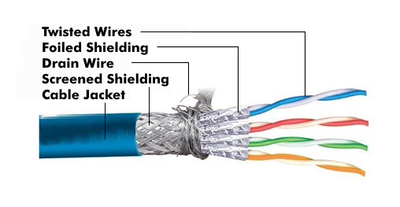

1. ***Unshielded Twisted Pair***

* *An unshielded twisted pair is widely used in telecommunication.*
  + *Ordinary telephone wires.*
  + *Weak immunity against noise & interferences.*
* *Following are the categories of UTP :*
  + *Category 1 : Used for telephone lines that have low-speed data.*
  + *Category 2 & 3 : It can support up to 4Mbps & 16Mbps.*
  + *Category 4 : It can Support up to 20Mbps for long distance communication.*
  + *Category 5 : It can support up to 200Mbps.*
* ***Advantages :*** 
  + *It is cheap.*
  + *Installation of the unshielded twisted pair is easy.*
  + *It can be used for high-speed LAN.*
* ***Disadvantages :*** 
  + *This cable can only be used for shorter distances because of attenuation.*

***Diagram :***

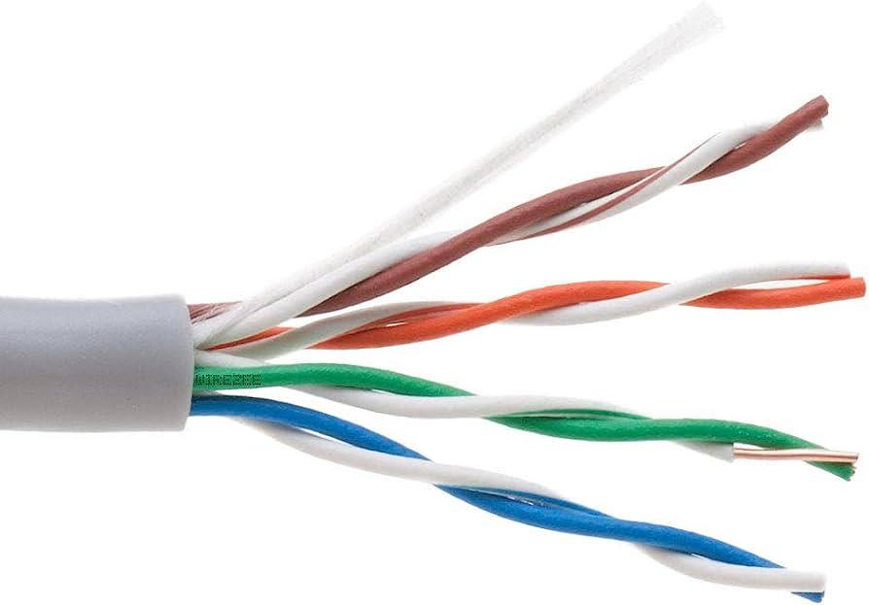

* + ***Diagram*** *:*

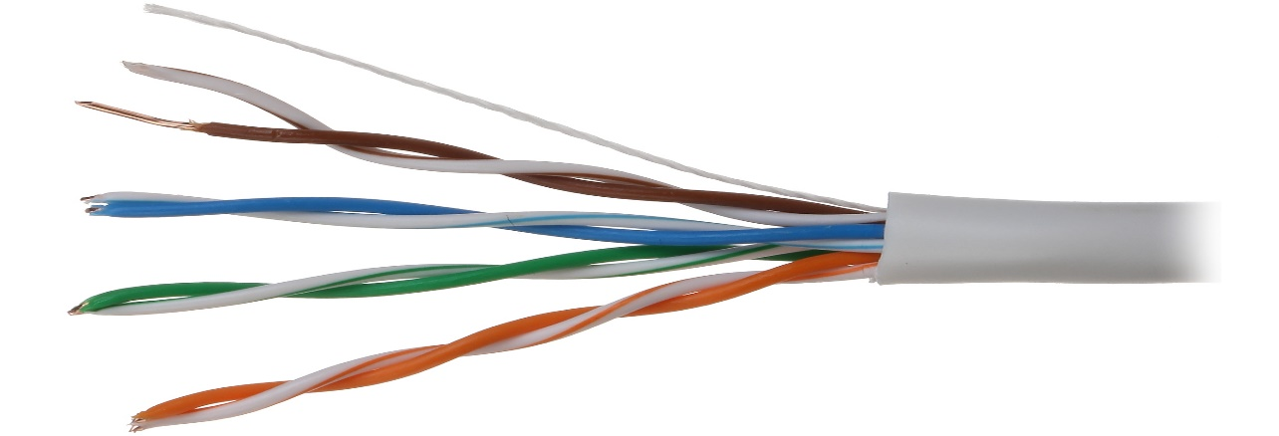

1. ***Network Cable Name :*** *Coaxial Cable*
   * ***Network Cable Type :***  *Guided*
   * ***Description :***

* *Coaxial cable is very commonly used transmission media, for example, TV wire is usually a coaxial cable.*
* *The name of the cable is coaxial as it contains two conductors parallel to each other.*
* *It has a higher frequency as compared to Twisted pair cable.*
* *It has excellent noise immunity.*
* ***Coaxial cable is of two types :***

1. ***Baseband transmission:****It is defined as the process of transmitting a single signal at high speed.*
2. ***Broadband transmission:****It is defined as the process of transmitting multiple signals simultaneously.*

* ***Advantages :***
  + *The data can be transmitted at high speed.*
  + *It has better shielding as compared to twisted pair cable.*
  + *It provides higher bandwidth.*
* ***Disadvantages :*** 
  + *It is more expensive as compared to twisted pair cable.*
  + *If any fault occurs in the cable causes the failure in the entire network*.
  + ***Diagram :***



1. ***Network Cable Name :*** *Fiber Optic Cable*
   * ***Network Cable Type :***  *Guided*
   * ***Description :***

* *Fibre optic cable is a cable that uses electrical signals for communication.*
* *Fibre optics provide faster data transmission than copper wires.*
* *A Fiber optics cable is made of glass or plastic and transmits signals in the form of light.*
* *They travel hundreds of miles significantly faster than those used in traditional electrical cables.*
* ***Core :*** *The optical fibre consists of a narrow strand of glass or plastic known as a core.*
* ***Cladding :*** *The concentric (*કેન્દ્રિત*) layer of glass is known as cladding.*
* ***Jacket :*** *The protective coating consisting of plastic is known as a jacket.*
* ***Advantages :*** 
  + *The fiber optic cable provides more bandwidth as compared copper.*
  + *The fiber optic cable carries the data at a longer distance as compared to copper cable.*
  + *High data rate and lower attenuation.*
  + ***Diagram :***

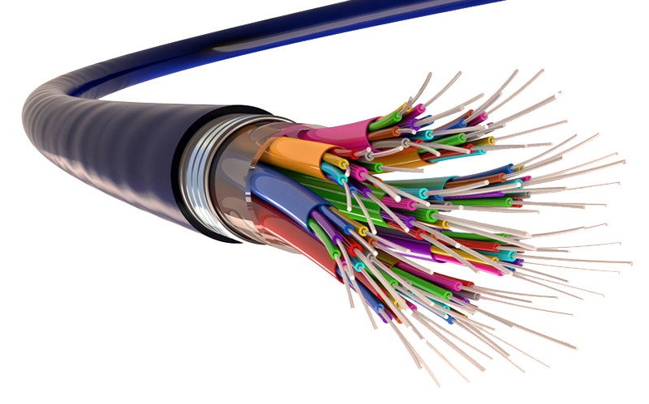

## *Give cross-wired cable and straight through cable diagram (Color Code wise).*

1. ***Cross-wired Cable Diagram (Color Code)***

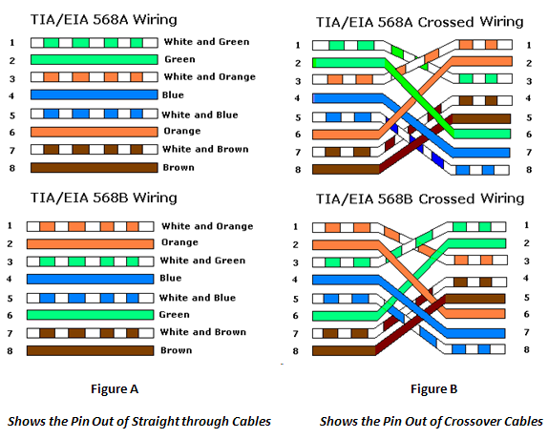

1. ***Straight Through Cable Diagram (Color Code)***

